DEPARTMENT OF BOTANY



DEPARTMENTAL TIMETABLES
ACADEMIC YEAR- (2025-26)

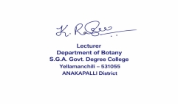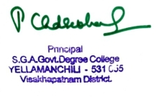
SIGNATURE OF LECTURER SIGNATURE OF PRINCIPAL


TIME TABLE FOR THE DEPARTMENT OF BOTANY 2025-2026
SEMISTER—I, III, V
DAY | SEM | 10:00-10:50 | 10:50-11:40 | 11:40-12:30 | 12:30-1:20 |  | 2:20-3:10 | 3:10-4:00 | 4:00-5:00
DAY | SEM | 1 | 2 | 3 | 4 |  | 5 | 6 | 7
MON | I |  |  |  |  | L  U  N  C  H  B  R  E  A  K | P1 Practical
MON | III | Vascular P | Plant Path |  | Plant Bio | L  U  N  C  H  B  R  E  A  K
MON | V | Plant Physio |  | P12 Practical |  | L  U  N  C  H  B  R  E  A  K |  | Organic F
TUE | I |  |  |  |  | L  U  N  C  H  B  R  E  A  K | P2 Practical
TUE | III | Plant Breed | Plant Path | P5 Practical (Major) |  | L  U  N  C  H  B  R  E  A  K
TUE | V | P13 Practical |  | Cell Biology |  | L  U  N  C  H  B  R  E  A  K | Organic F | Mushroom
WED | I |  |  |  |  | L  U  N  C  H  B  R  E  A  K
WED | III | Vascular P |  | P7 Practical |  | L  U  N  C  H  B  R  E  A  K | Plant Bio
WED | V | Mushroom | Cell Biology |  |  | L  U  N  C  H  B  R  E  A  K | P14 Practical
THU | I |  |  | Diversity of T | Diversity of M | L  U  N  C  H  B  R  E  A  K
THU | III |  | Plant Bio | P6 Practical |  | L  U  N  C  H  B  R  E  A  K | Vascular P
THU | V | Cell Biology |  | Plant Physio |  | L  U  N  C  H  B  R  E  A  K | P15 Practical
FRI | I |  | Diversity of M | Diversity of T |  | L  U  N  C  H  B  R  E  A  K
FRI | III | Plant Breed |  | P8 Practical |  | L  U  N  C  H  B  R  E  A  K
FRI | V | Plant Physio | Mushroom |  |  | L  U  N  C  H  B  R  E  A  K
SAT | I |  |  | Diversity of M | Diversity of T | L  U  N  C  H  B  R  E  A  K
SAT | III | Plant Path | Plant Breed | P5 Practical (Minor) |  | L  U  N  C  H  B  R  E  A  K
SAT | V |  |  |  | Organic F | L  U  N  C  H  B  R  E  A  K

THEORY CLASSES: 33 PRACTICAL CLASSES: 44 TOTAL CLASSES: 77

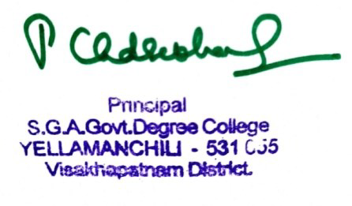
SIGNATURE OF PRINCIPAL
TIME TABLE FOR THE DEPARTMENT OF BOTANY 2025-2026
SEMISTER—II, IV, VI
DAY | SEM | 10:00-10:50 | 10:50-11:40 | 11:40-12:30 | 12:30-1:20 |  | 2:20-3:10 | 3:10-4:00 |  | 4:00-5:00
DAY | SEM | 1 | 2 | 3 | 4 |  | 5 | 6 |  | 7
MON | I |  |  |  |  | L  U  N  C  H  B  R  E  A  K | C-3 PRACTICAL
MON | IV | C-10 | C-3 | C-11 |  | L  U  N  C  H  B  R  E  A  K
MON | VI |  |  |  |  | L  U  N  C  H  B  R  E  A  K |  |  |  | LIS
TUE | I |  |  |  |  | L  U  N  C  H  B  R  E  A  K | C-4 PRACTICAL
TUE | IV | C-9 | C-4 | C-10 PRACTCAL |  | L  U  N  C  H  B  R  E  A  K |  | C-11
TUE | VI |  |  |  |  | L  U  N  C  H  B  R  E  A  K |  |  |  | LIS
WED | I |  |  |  |  | L  U  N  C  H  B  R  E  A  K
WED | IV | C-10 | C-4 | C-9 PRACTICAL |  | L  U  N  C  H  B  R  E  A  K
WED | VI |  |  |  |  | L  U  N  C  H  B  R  E  A  K |  |  |  | LIS
THU | I |  |  | C-4 | C-3 | L  U  N  C  H  B  R  E  A  K
THU | IV | C-4 | C-9 |  |  | L  U  N  C  H  B  R  E  A  K | C-3 PRACTICAL( MINOR)
THU | VI |  |  |  |  | L  U  N  C  H  B  R  E  A  K |  |  |  | LIS
FRI | I |  | C-3 | C-4 |  | L  U  N  C  H  B  R  E  A  K
FRI | IV | C-9 | C-3 | C-10 |  | L  U  N  C  H  B  R  E  A  K | C-11 PRACTICAL
FRI | VI |  |  |  |  | L  U  N  C  H  B  R  E  A  K |  |  |  | LIS
SAT | I |  |  | C-3 | C-4 | L  U  N  C  H  B  R  E  A  K
SAT | IV | C-11 |  | C-3 |  | L  U  N  C  H  B  R  E  A  K | C-4 PRACTICAL(MINOR)
SAT | VI |  |  |  |  | L  U  N  C  H  B  R  E  A  K |  |  |  | LIS

THEORY CLASSES: 33 PRACTICAL CLASSES: 28 TOTAL CLASSES: 61

SIGNATURE OF PRINCIPAL

